Telco
John Wensink
MIS445 - Statistics in Business Analytics
Colorado State University-Global Campus
Dr. Alin Tomoiaga
October 18, 2020

Telco
Here are parts one and two for module five critical thinking.
Construct the Plots
Amazon Close Plot | Google Close Plot | Amazon Close TS | Google Close TS
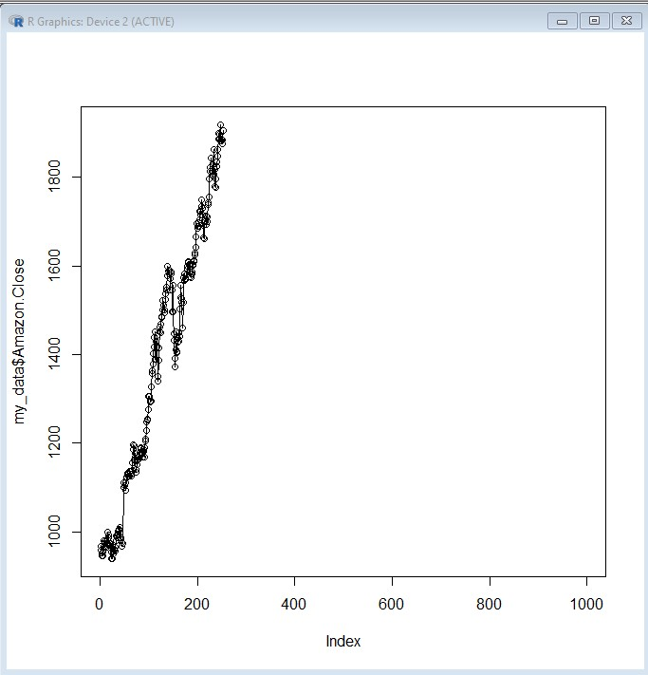 | 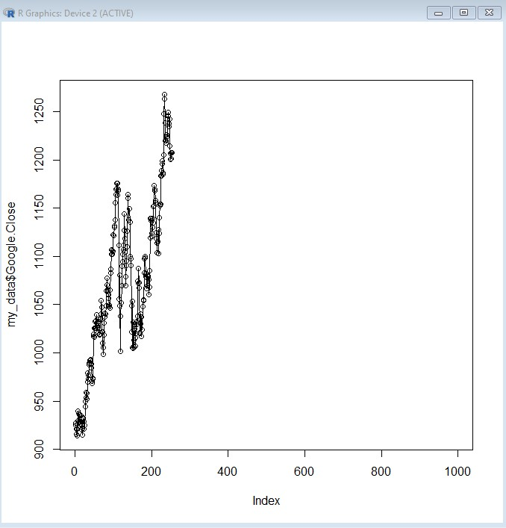 | 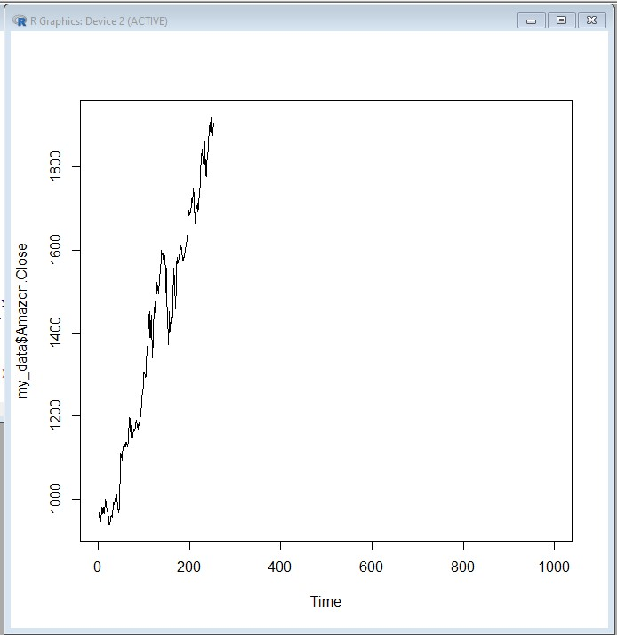 | 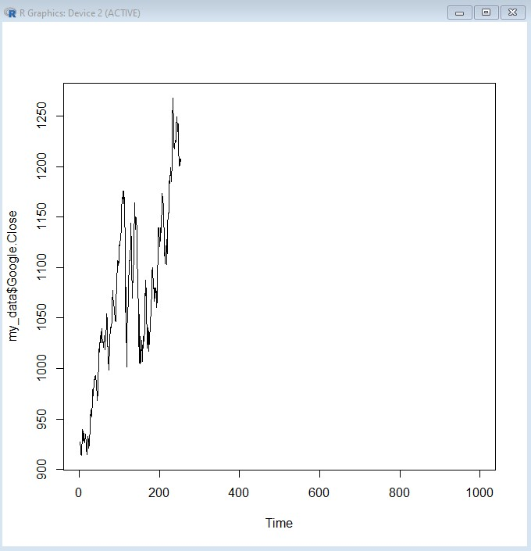
Amazon Return Plot | Google Return Plot | Amazon Return TS | Google Return TS
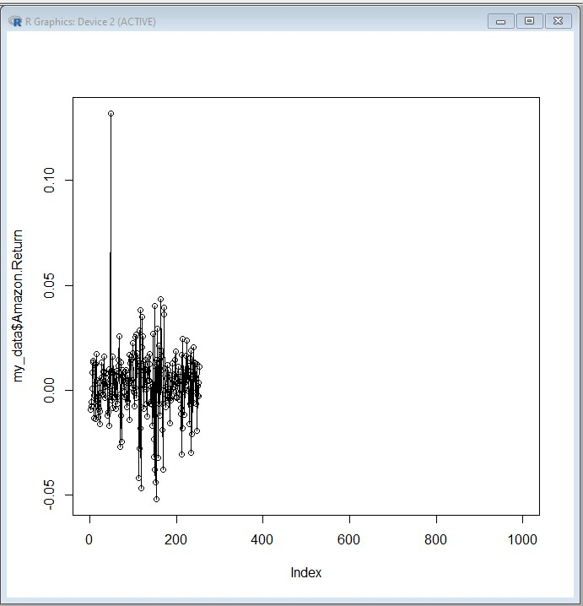 | 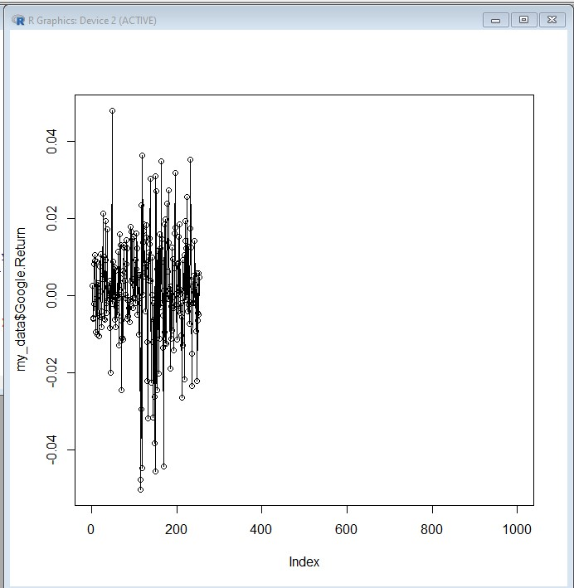 | 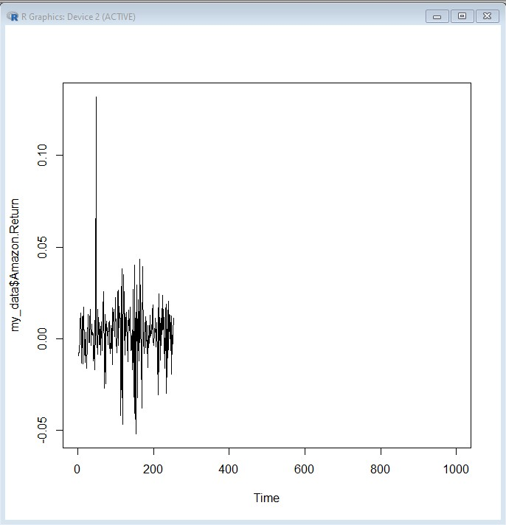 | 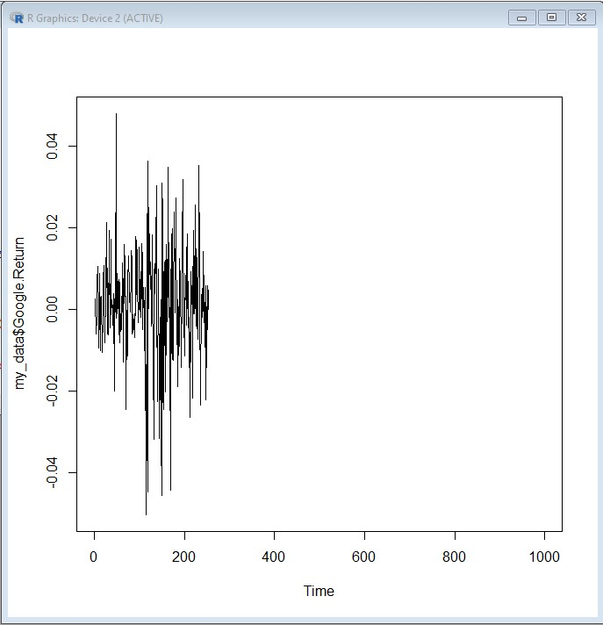

When comparing and contrasting the two stocks GOOG and AMZN, it is easy to lose sight of the fact that the company’s market capitalization is equal to the share price times the shares sold. The plots which compare the close prices of the shares is still useful in exploring relative trends. We can see that AMZN had a somewhat steeper ascent prior to the 2008 financial crisis, but not that much better than GOOG. When the crisis hit, AMZN’s shares were less severely impacted for a shorter amount of time than GOOG, however, the slope of GOOG recovery from the crisis seems slightly steeper than AMZN. For closing prices, I prefer the standard plot over the ts plot as the shading catches my eye better for spotting trends. Realistically all of these charts need to be zoomed in, as nearly half of the real estate available for the chart is blank space. Examining the Return Series section of charts we can see that this function is that of a +/- oscillator. What this series is a volume histogram whose reflection of high or low volume trading adds or subtracts weight from the relative price movements we see depicted here. These charts that GOOG has higher Historical Volatility than AMZN, price swings are more dramatic and the price of stock options will be higher, as a result, this has on the forward-looking Implied Volatility of the underlying asset. Again, these charts could be zoomed in to enhance detail, it is difficult to interpret trends with the data bunched together horizontally.

AMZN vs GOOG Return Series
Based on the tickers Return Series data, would it be possible to hypothesize that ‘the mean AMZN Return Series is higher than that of GOOG?
What would be an appropriate test?
Seeing as we are examining two completely different corporate entities we would need to use an independent t-test. Seeing as we are testing to see if μ of AMZN returns are greater than μ of GOOG, we will set GOOG to population-1 and AMZN to population-2 and run a left-tailed independent t-test to test our hypothesis that μ1<μ2.
What would be the null hypothesis and its alternative?
Let us set H₀ μ1=μ2.
Let us postulate a left-tailed alternative H₁=μ1<μ2.
Let α=0.05, a 95% confidence level.

Testing in R.
> t.test(my_data$Google.Return, my_data$Amazon.Return, alternative="less", paired=FALSE)
Welch Two Sample t-test
data: my_data$Google.Return and my_data$Amazon.Return
t = -1.2108, df = 489.05, p-value = 0.1133
alternative hypothesis: true difference in means is less than 0
95 percent confidence interval: -Inf 0.0006035938
sample estimates:
mean of x mean of y
0.001159563 0.002831278

The decision in the context of the problem.
Based on the data presented in the t-test described above, we found a p-value of 0.011, as such we can state that H₀ μ1=μ2 at confidence level 2σ. We accept H₀ and reject the alternative H₁. Within the context of this hypothesis, we can state that the AMZN mean return was greater than GOOG as described by the data provided. Since our p-value was over double our alpha value, we are unable to reject our null hypothesis and can not state that AMZN had higher mean revenue than GOOG.

